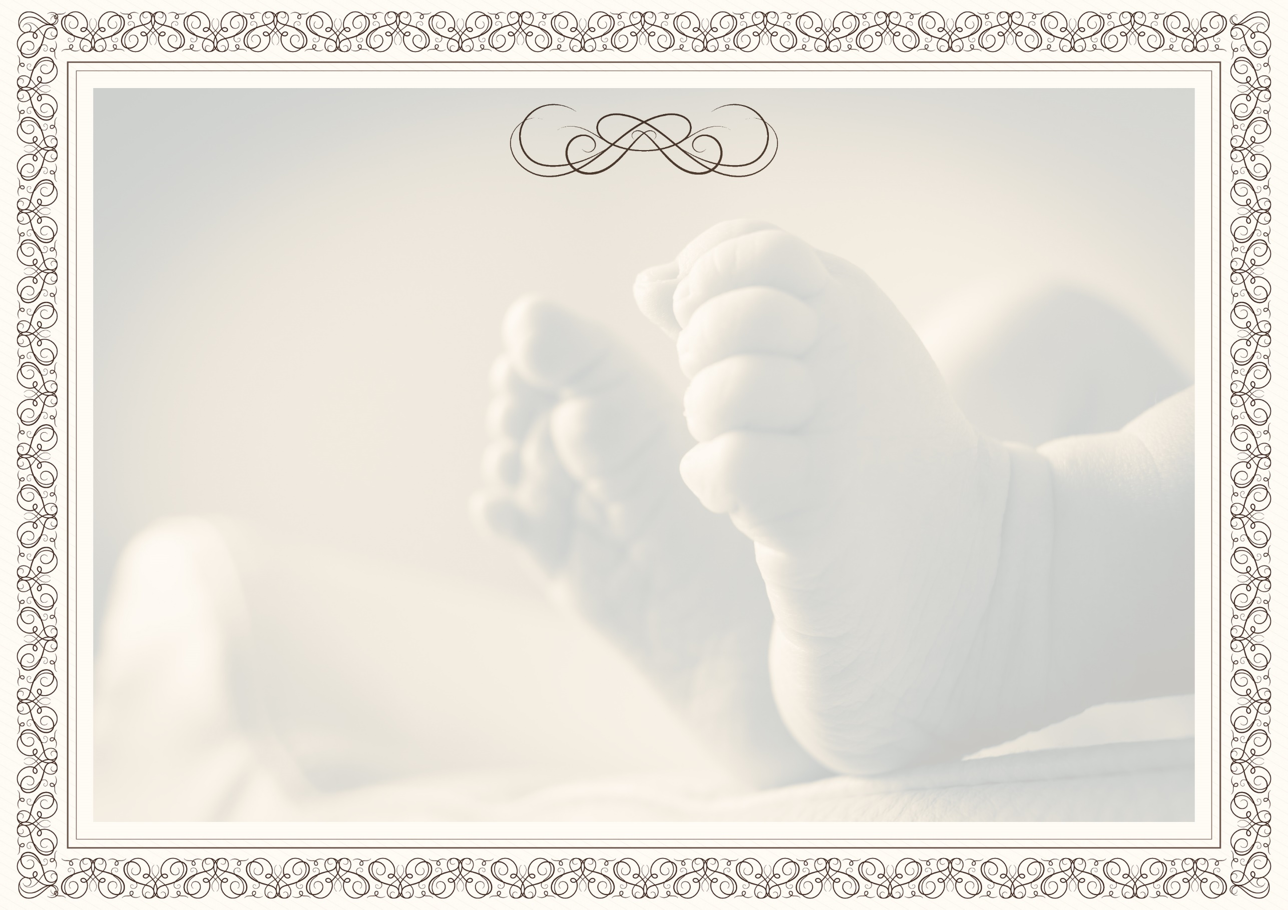

Ninong & Ninang

Joyralyn Bantilan
Marjorie Mailed
Dianara Lumimbay
Barbelyn Biol
Meralyn Cosme
Andrea Labiran
Genilda Lumimbay
Christita Salas

Julito Biol
Marjun Vicente
Michael Tundag
Jennard Lumimbay
Christian Rabaya
Remlin Rojas
Ruel Cusong
Mario Jr. Cusong
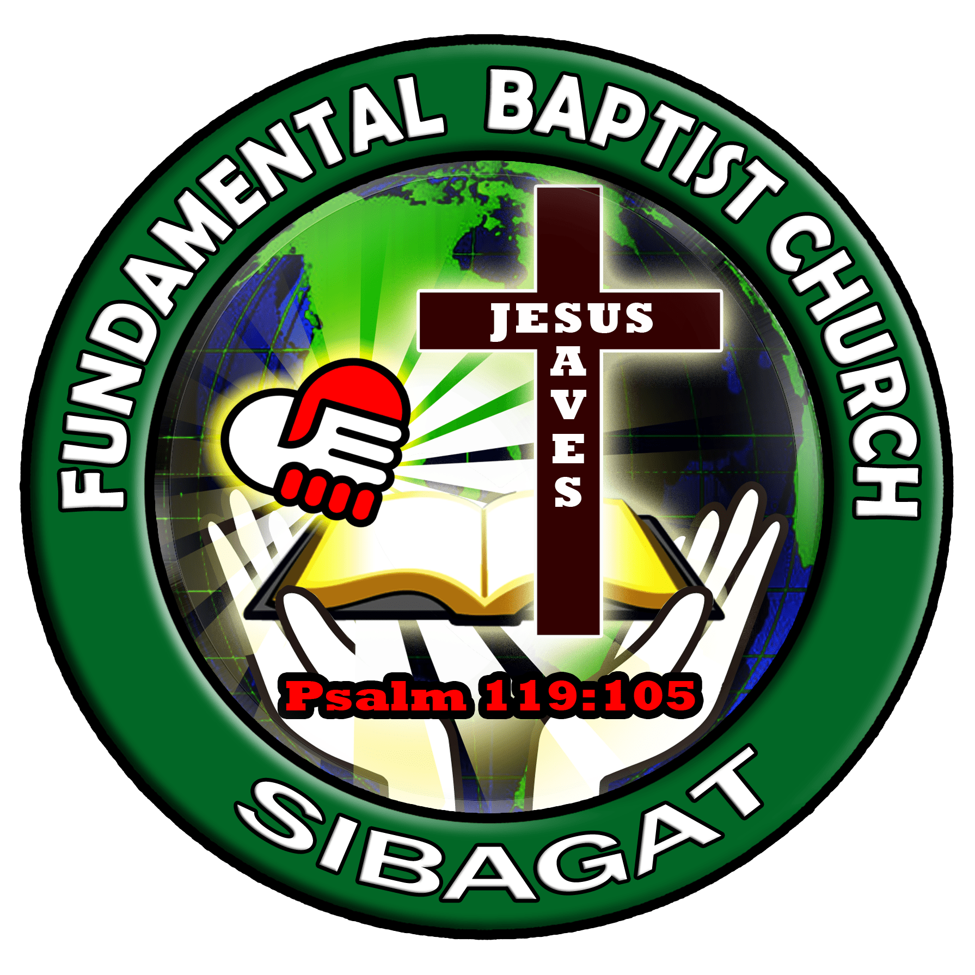
"Children are a heritage from the Lord, offspring a reward from him.".
Psalm 127:3

